**AWS SETUP**

1. Navigate to “https://aws.amazon.com/account/sign-up” and crate and account:

1. 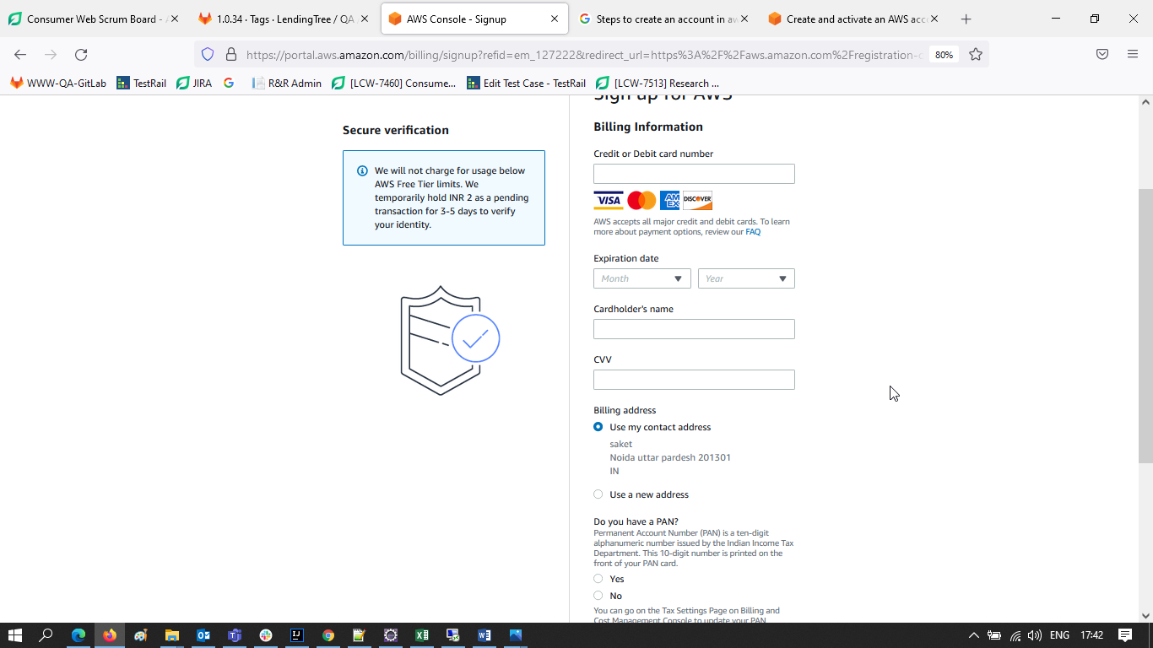

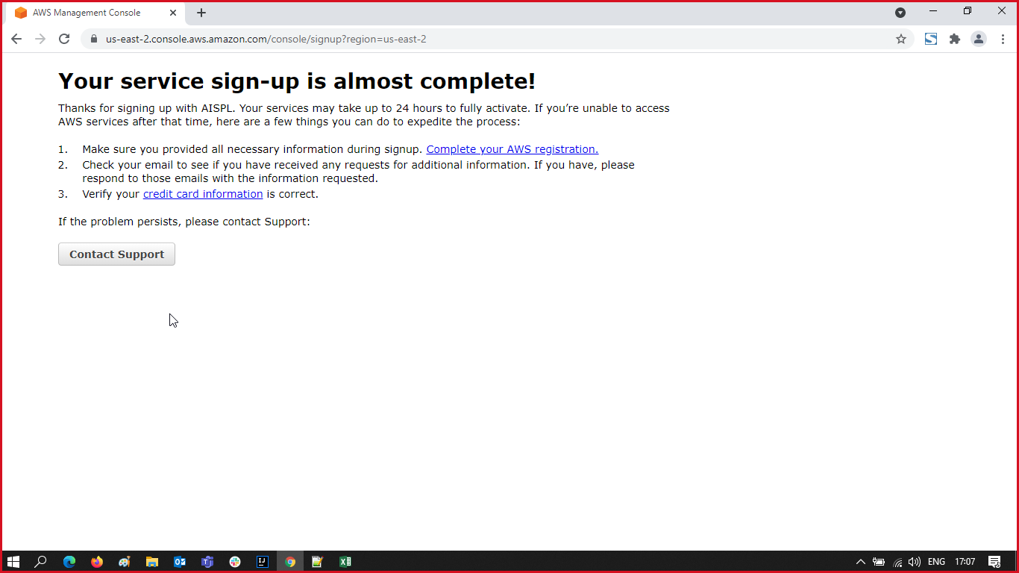

1. Once Account Created
2. Click Instance

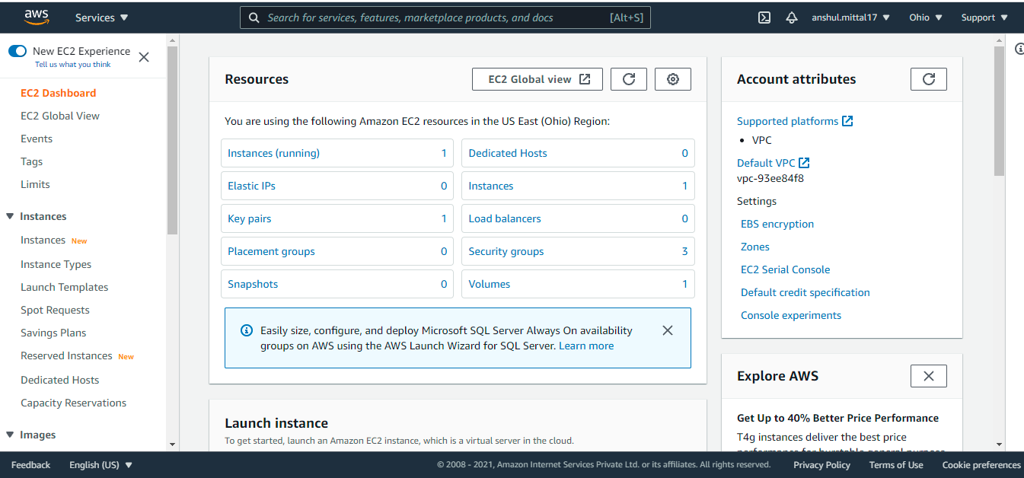

1. Click on Launch Instance
2. Select and create a Microsoft Windows Server 2019 Base instance

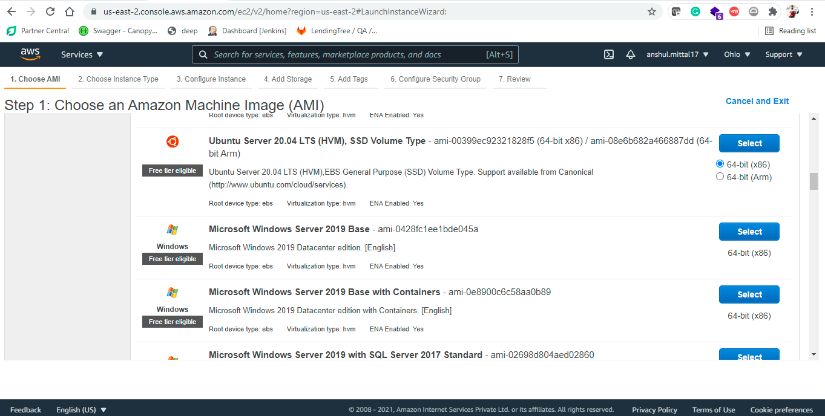

1. Click on Review and launch button to continue

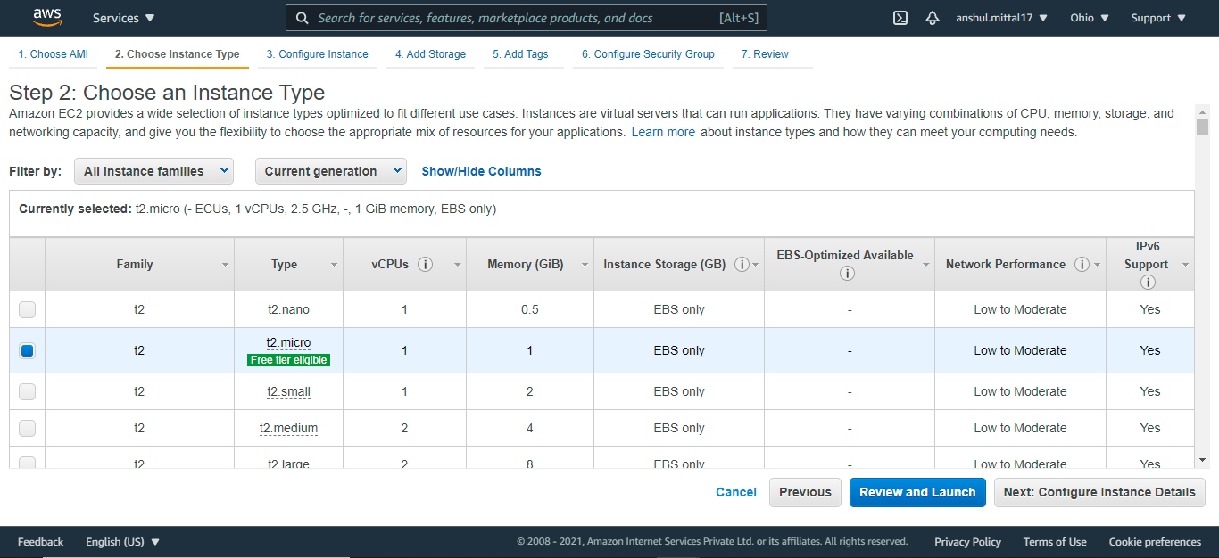

1. Validate the system configuration and Click Launch button

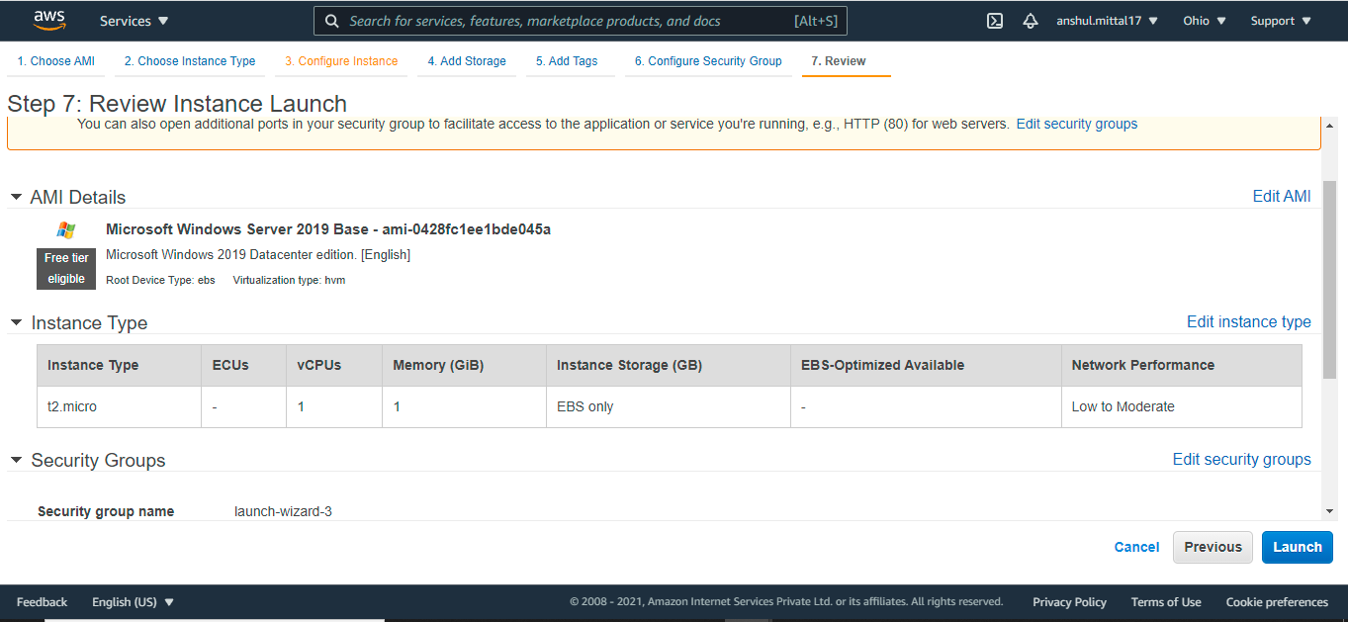

1. Select “Create a new Key Pair” and RSA
2. Add Key Pair Name
3. Click “Download Key Pair”

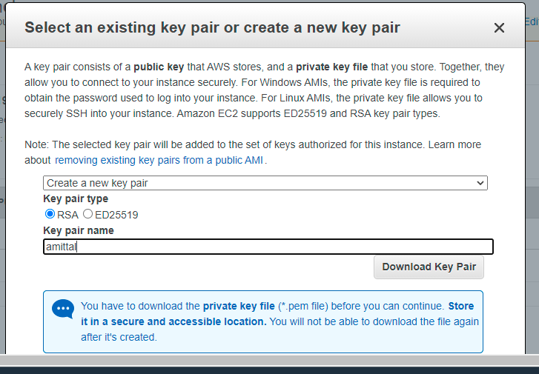

1. Click Launch Instance

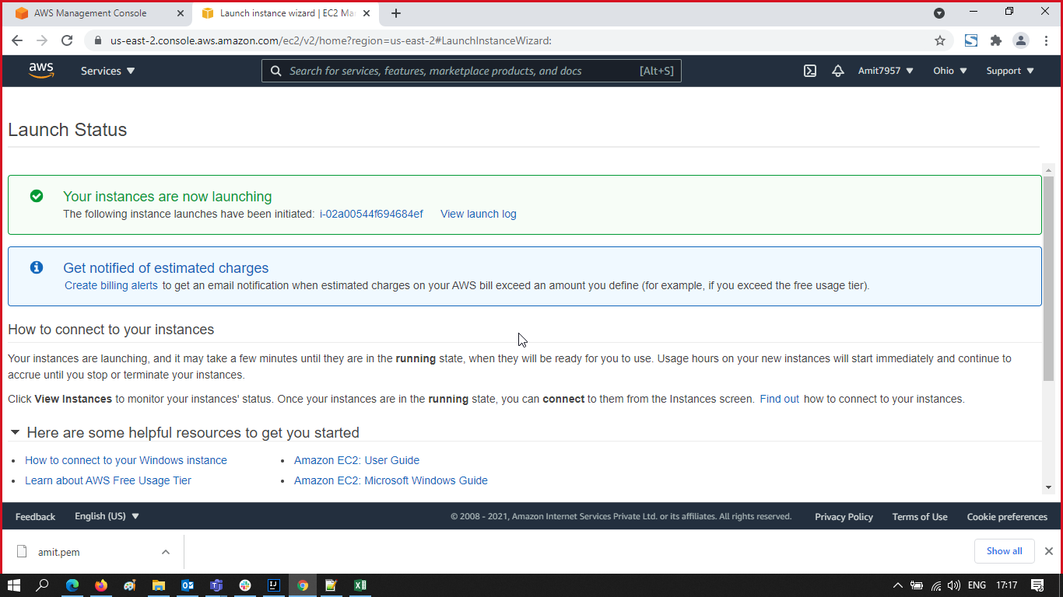

1. Click on following instance launch link – [i-005389f83ab2f8f1e](https://us-east-2.console.aws.amazon.com/ec2/v2/home?region=us-east-2#Instances:search=i-005389f83ab2f8f1e;sort=instanceId)

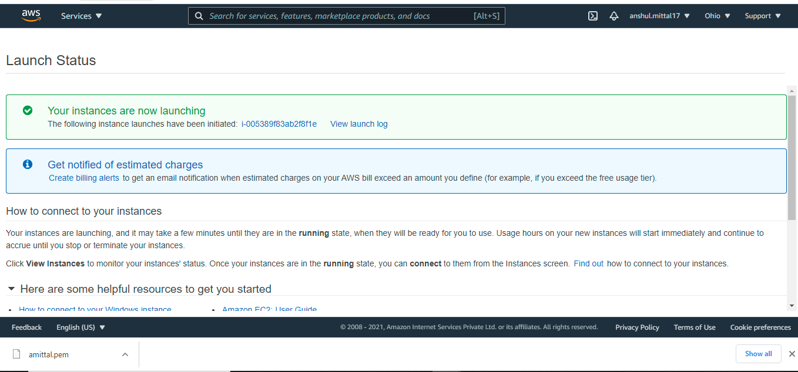

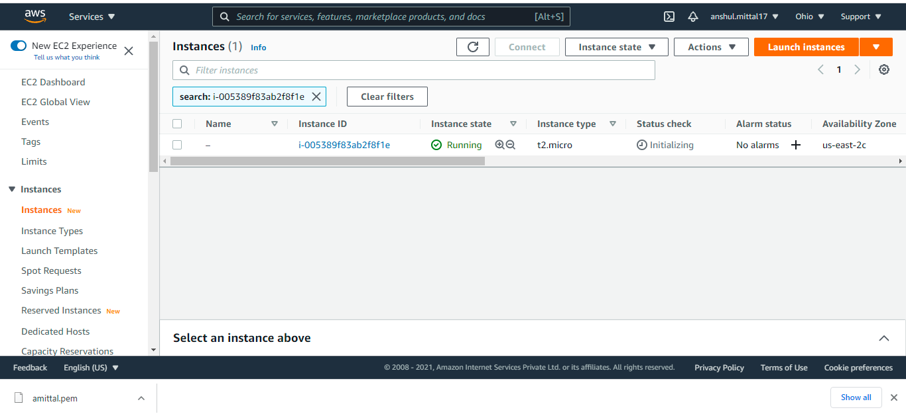

1. Check the Instance
2. Click on Connect

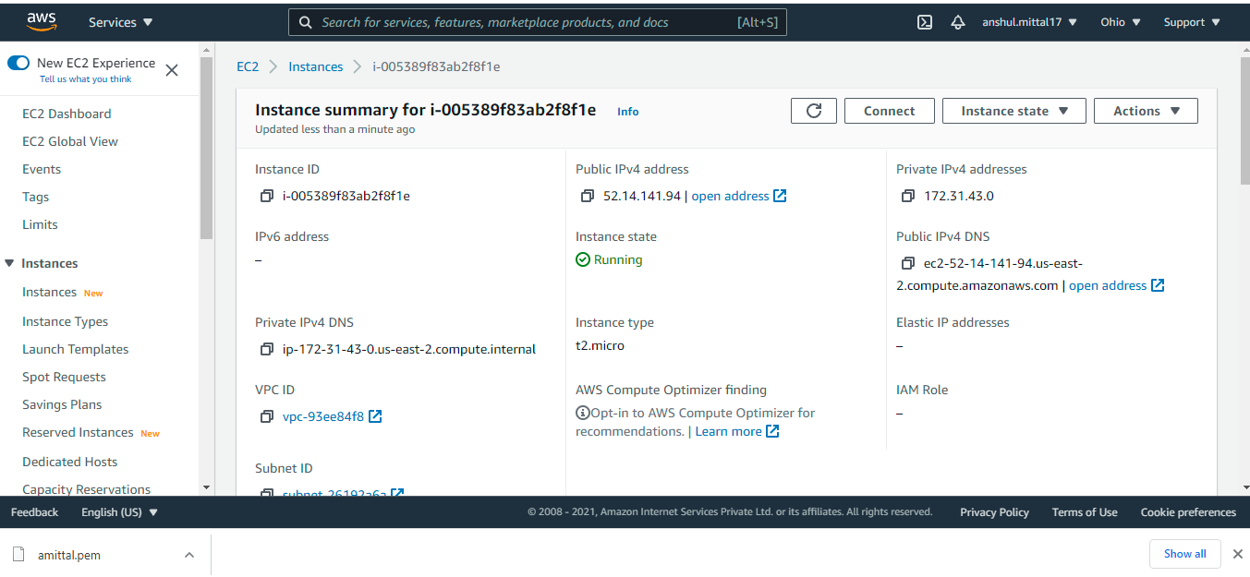

1. Click “RDP Client”

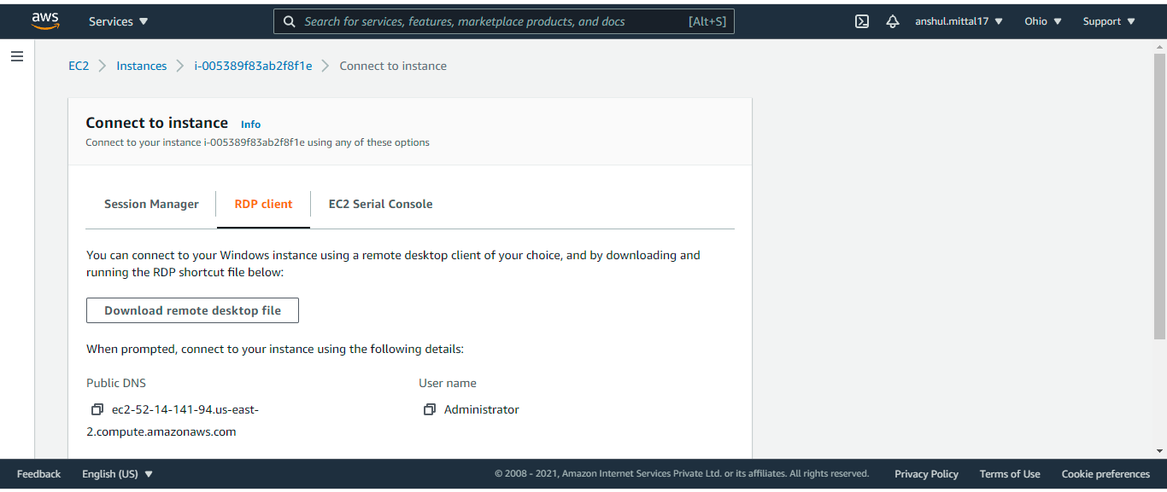

1. Click “Download remote desktop file” – it downloads ec2.us-east-2.compute.amazonaws.com
2. Click “Get password”

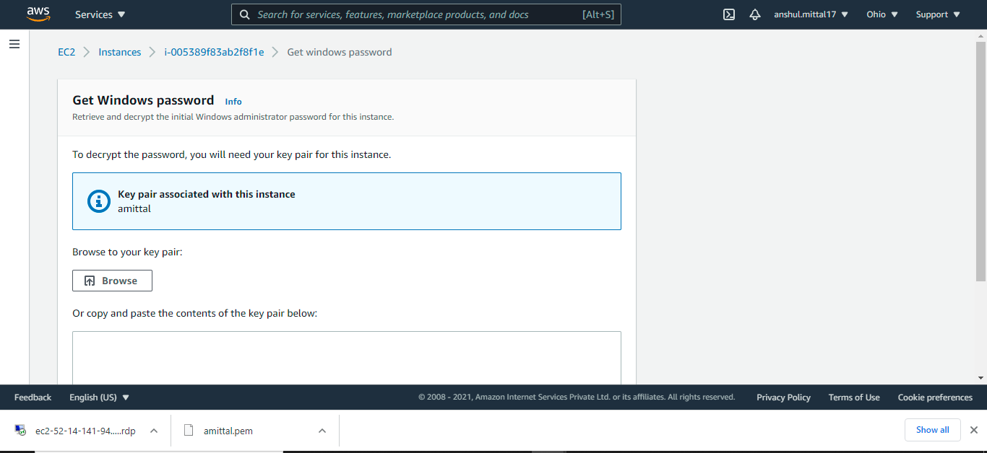

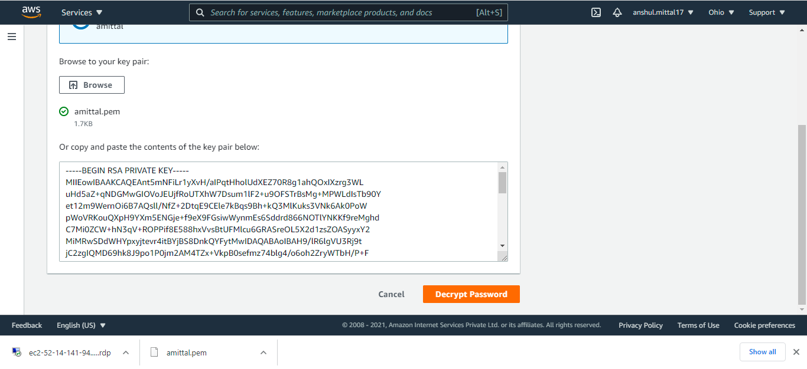

1. Click Browser and add key pair file here as per downloaded in Step 10.
2. Click “Decrypt Password”

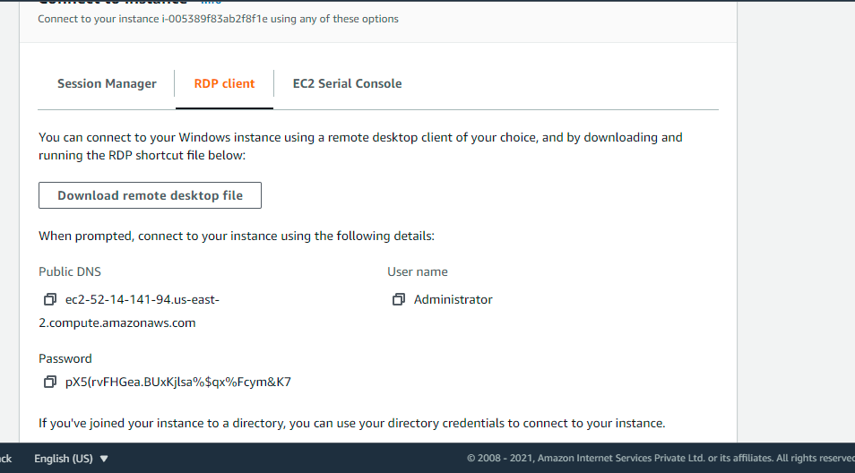

1. Copy the Password and Store for reminder
2. Click on file as downloaded in Step 16.

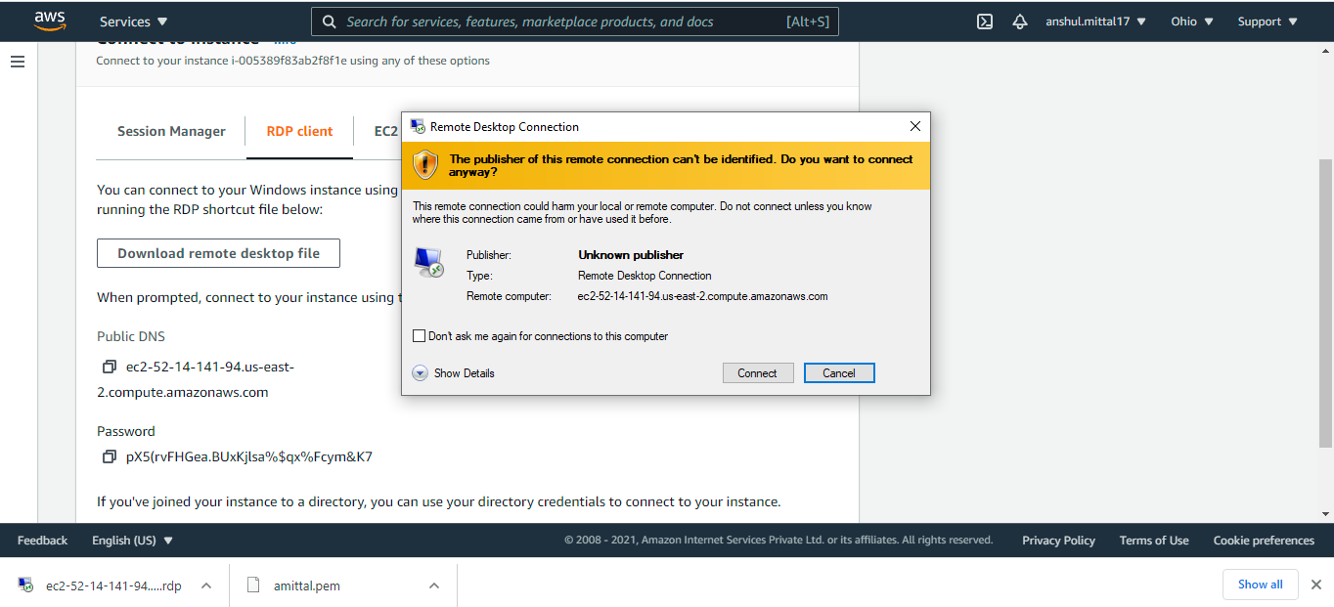

1. Click on Connect
2. Enter Password as store in Step 20

**INSTALL JAVA AND MAVEN**

1. Download and install JAVA 8
2. Download Maven
3. Set Environment Variable

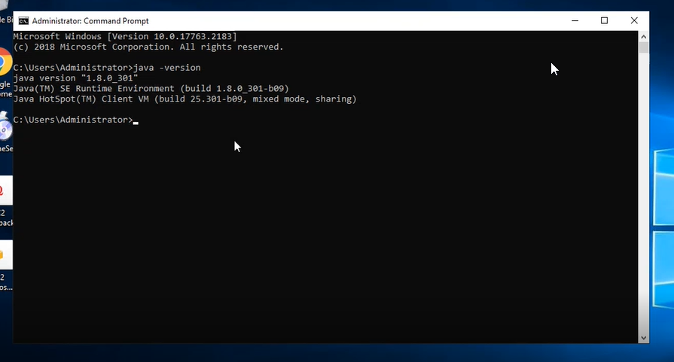

**CREATE PROJECT AND PUSH IN GITHUB**

1. Go to Eclipse and Create a project

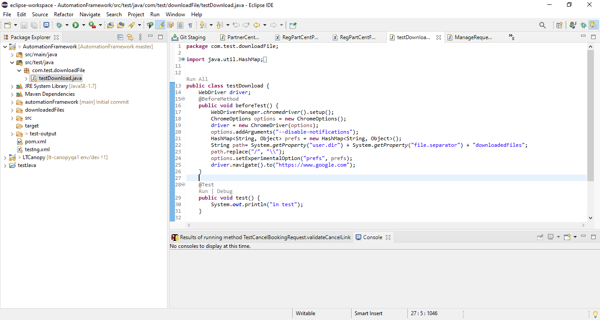

1. Create a Github Account
2. Launch command prompt
3. Navigate to the Project folder
4. Initialize GIT

git init

Add Remote Repository to the Origin and enter GIT credentials

git remote add origin https://github.com/anshulmittal292/automationFramework.git

1. Add all the files to Repository.

git add .

1. Commit the code.

git commit -m "message"

1. Push the Code to Master branch

git push origin master

1. Verify Code is available in GIT

**SETUP JENKINS**

1. Navigate to <https://www.jenkins.io/download/>

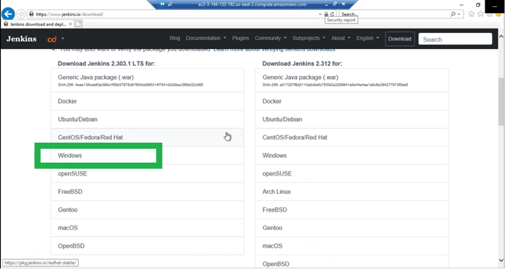

1. Download Windows file

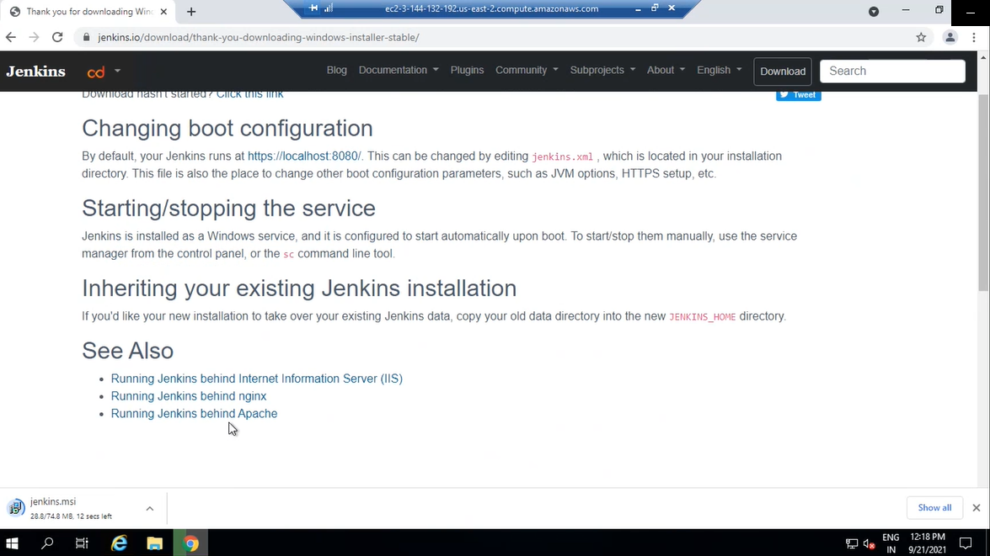

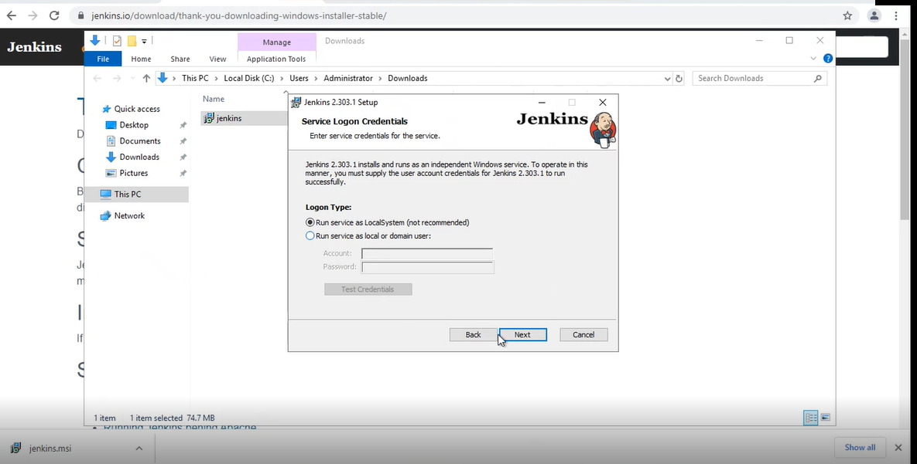

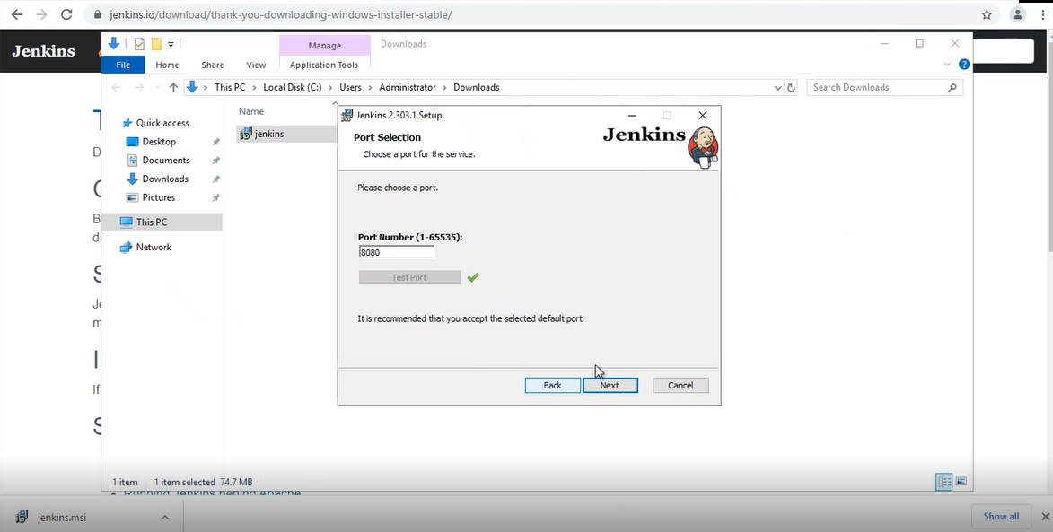

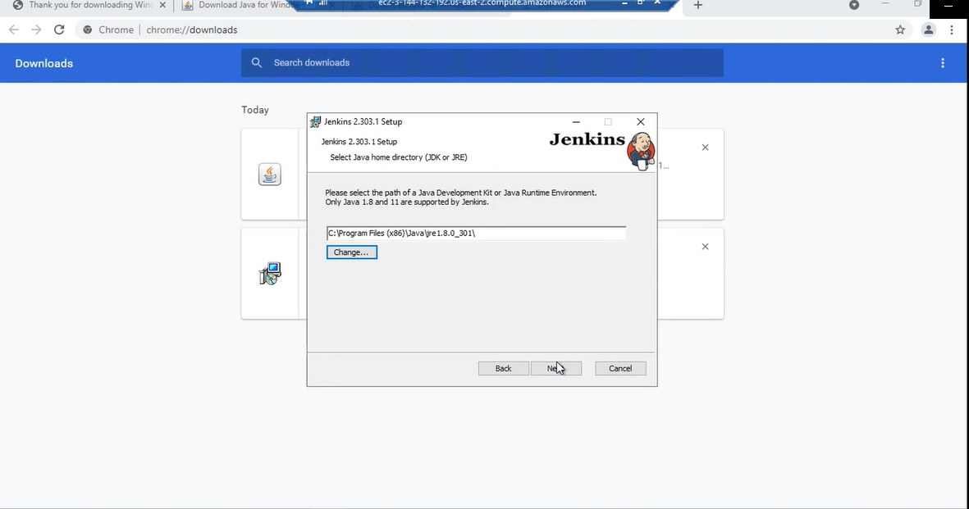

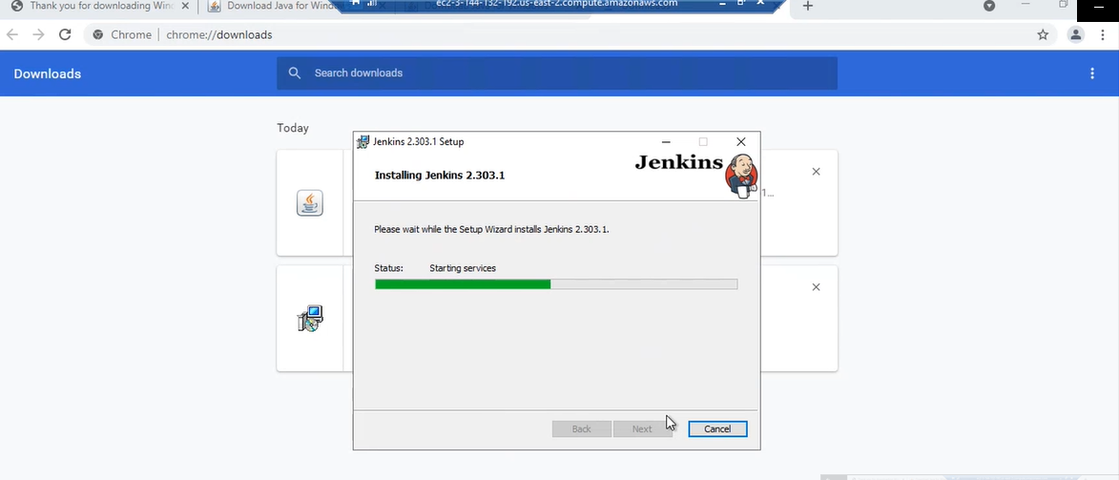

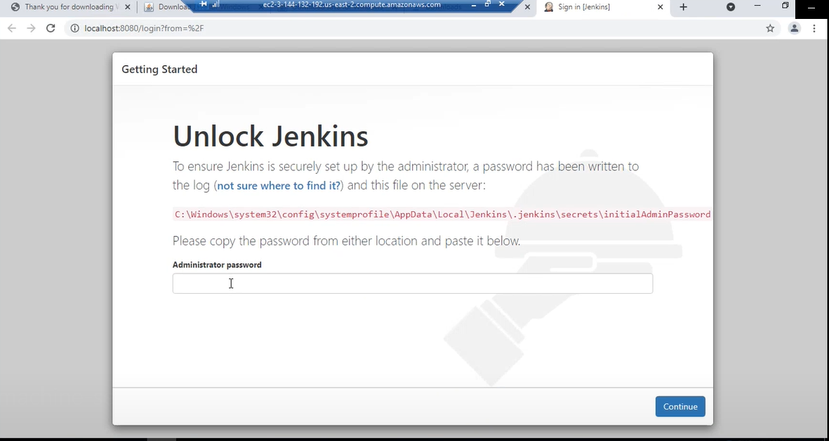

1. Copy path and go to respective file

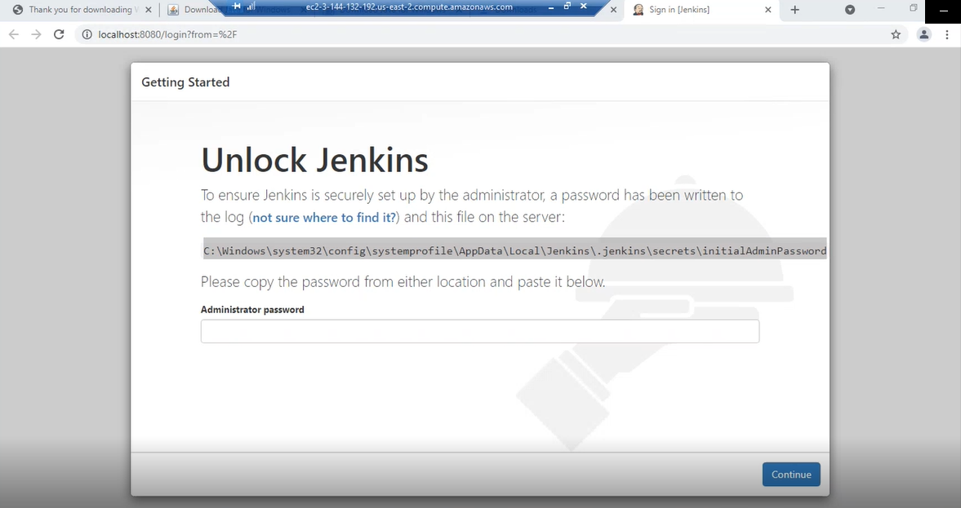

1. Open file Jenkins.err and copy the password from there
2. Paste Password and Login into Jenkins

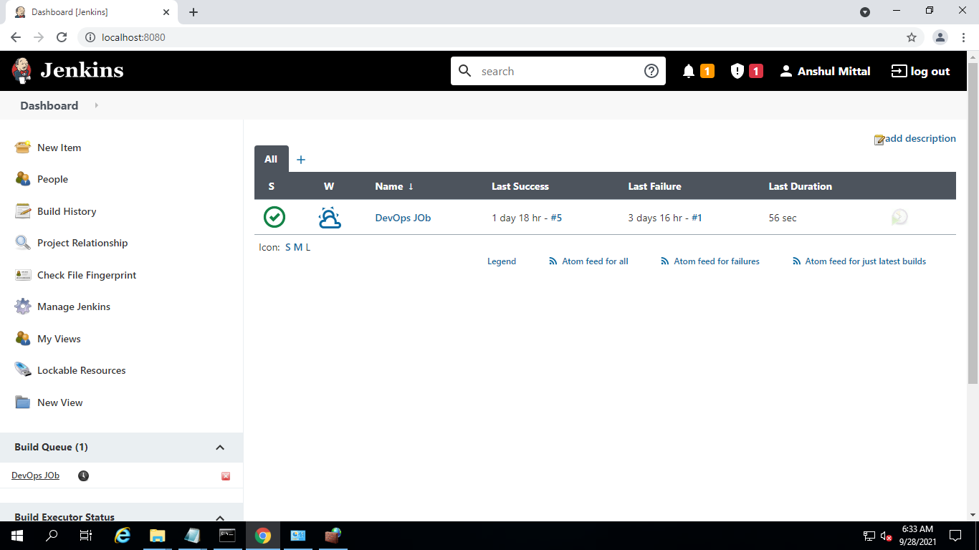

1. Install Maven plugin from Manage Jenkins
2. Select and Click “Install without restart”.
3. Click on “Manage Jenkins”
4. Click on “Global Tool Configuration”
5. Add “JAVA_HOME”

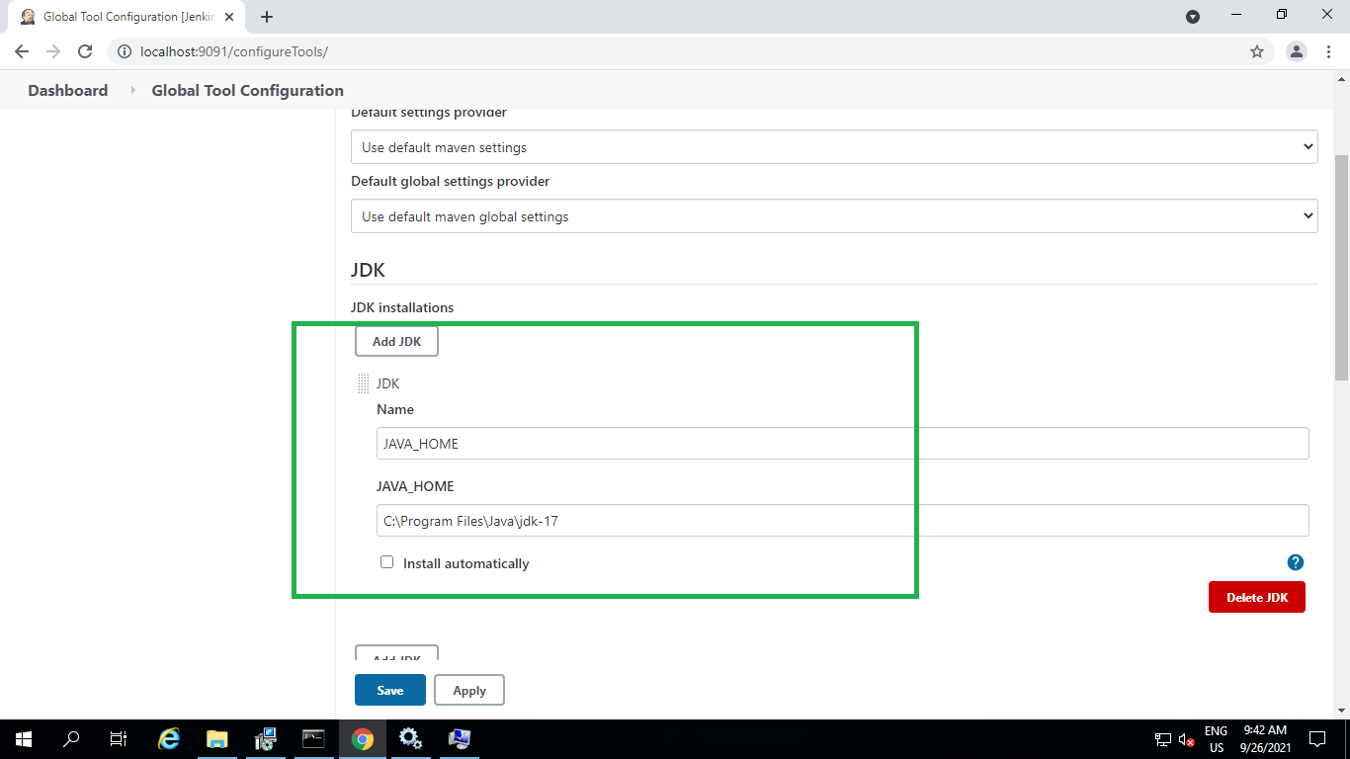

1. Add Maven Path

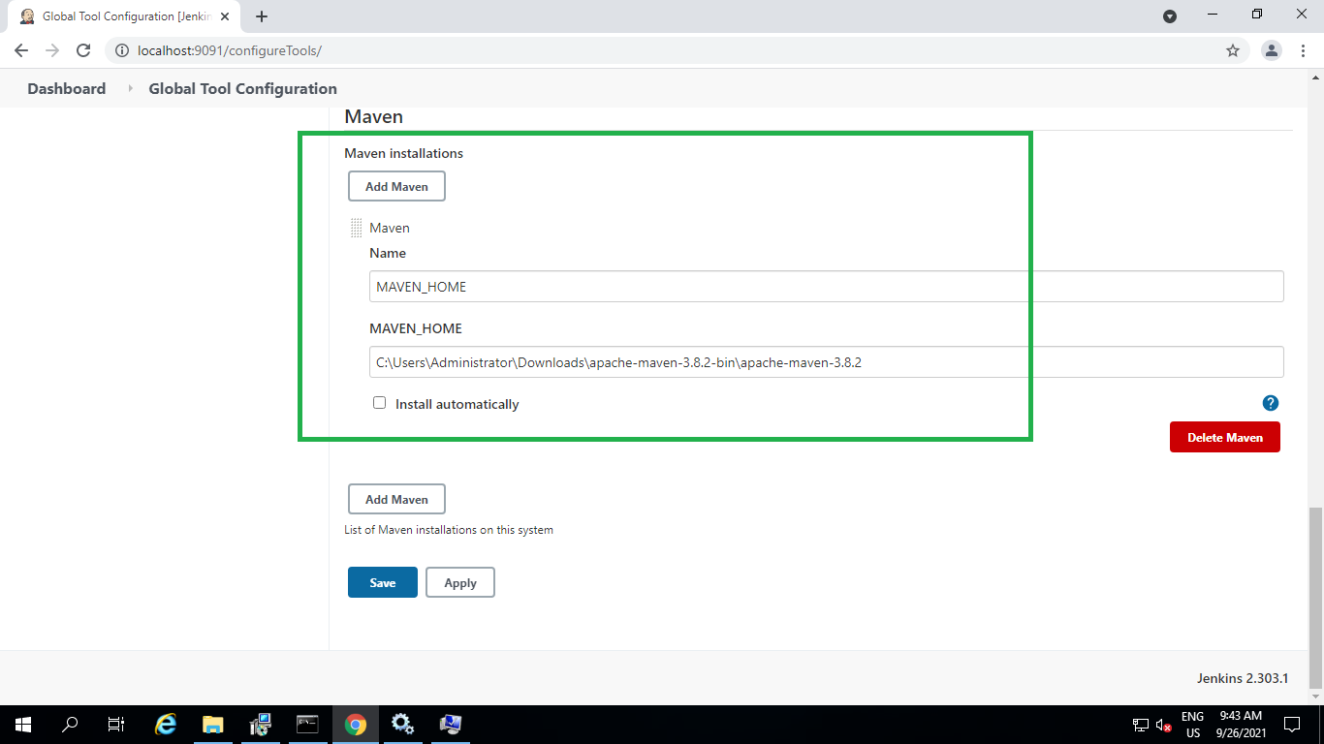

1. Click Apply
2. Click Save.
3. Click on Dashboard
4. Click on New Item
5. Enter Project Name in “Enter an item name”
6. Select “Maven” Project
7. Click “OK”
8. Click on Tab “Source Code Management”
9. Add Github repository URL

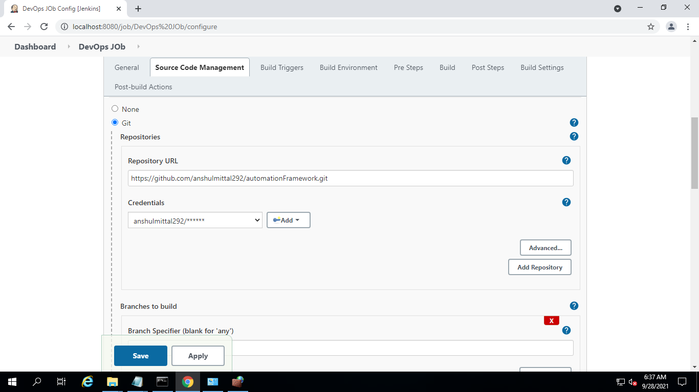

1. Click Apply and Save
2. Click on Dashboard
3. Select the project and click Build Now
4. Check console output

